Registry Tiger Team Requirements Document

Stephen Sullivan

Exported on Jan 15, 2020

Table of Contents

1 Overview 3

2 NIEM Public Registry 4

2.1 Assumptions 4

2.2 Limitations 4

2.3 Constraints 4

2.4 Risk 4

2.5 Scope 4

2.6 Functional Requirements 6

2.7 Use Cases 6

2.7.1 UC 1: Access NIEM.gov Public IEPD Search Page 6

2.7.2 UC 2 Conduct Registry Search 6

2.7.3 UC3 Display Search Results 7

2.7.4 UC4 Save Search Results 8

2.8 Non-Functional Requirements 8

3 NIEM Restricted Registry/Repository 9

4 NIEM Public Registry/Repository 10

# Overview

# NIEM Public Registry

## Assumptions

* The NIEM Public Registry will be hosted on [NIEM.gov](http://NIEM.gov)
* The system will not be populated with all known historical data at start-up.
* The registrant can restrict sensitive information from being displayed to the User (Search Customer).

## Limitations

* User profiles are not supported in the NIEM.gov Public Registry.
* No Login/Login Security is available in the NIEM.gov Public Registry.
* Not all metadata provided by a registrant is necessarily available as user searchable criteria (example: registration date).

## Constraints

* Drupal 8 is the open source content management platform and development framework selected for [NIEM.gov](http://NIEM.gov) and therefore the NIEM Public IEPD Registry start-up.
* DHS will provide the registry infrastructure, Drupal 8 platform and framework, overall administration, maintenance and governance under which the NIEM Public Registry will operate.
* System operation must comply with DHS standards, policy and rules.

## Risk

## Scope

A **scope diagram** is a graphical outline of the main functionality of the system. This diagram can bring focus to the entire project as it identifies the boundaries of the system.  The identification of functionality outside the system (actors) and inside the system (use cases) leads to definition of system boundaries. A **use case diagram** is a diagram that shows relationships between the users of the system (actors) and functionality offered by the system (use cases). It highlights the major piece of functionality offered by the system and identifies the usage of the functionality. A use case is a description of the interaction between the system and the user of the system for a particular process or functionality offered by the system. An **actor** is an entity (a person, group, organization, another system) that interacts with a system in order to provide information to, or receive information from, the system.

The NIEM Public Registry Scope diagram shows several use cases and the actors that are either providing information for a Use Case or receiving information from a Use Case. The basic functionality of the NIEM Public Registry is for a registrant to input IEPD metadata into the registry for validation and publication to the registry by the NIEM Management Office (NMO) and for a User (Search Costumer) to search the registry database and retrieve metadata about registered IEPDs.  Note that only the high level use cases are listed below.

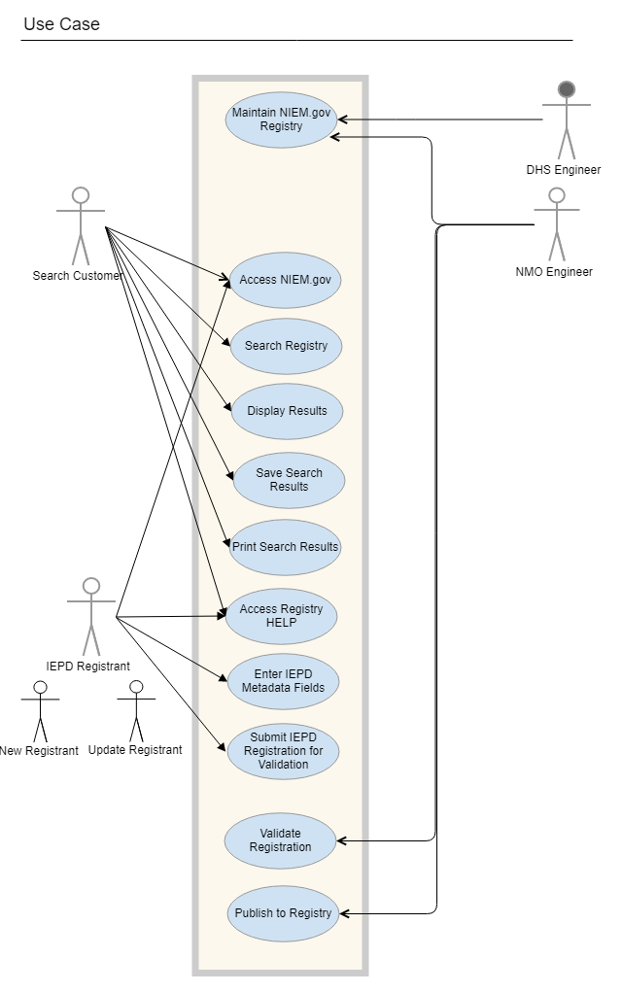

## Functional Requirements

The functional requirements describe the core functionality of the application.

## Use Cases

### UC 1: Access NIEM.gov Public IEPD Search Page

#### Purpose

A User accesses the public NIEM.gov Homepage and navigates to the NIEM Public Registry Search page.

#### Actors

* User (Search Customer)

#### Pre conditions

* User has access to internet

#### Post conditions

* The IEPD Search Page is displayed.

#### Main Flow

* The user accesses the NIEM.gov Homepage.
* The User navigates to the NIEM Public Registry Search page.

#### Exceptions

* The [NIEM.gov](http://NIEM.gov) website cannot be accessed and a HTTP 404 error message is returned.
* The NIEM IEPD Public Registry Search Page cannot be accessed and a HTTP 404 error message is returned.

### UC 2 Conduct Registry Search

#### Purpose

The User (Search Customer) accesses the [NIEM.gov](http://NIEM.gov) site, navigates to the IEPD Registry Search page, enters IEPD search parameters and conducts a registry search.

#### Actors

* User (Search Customer)

#### Pre conditions

* IEPD Search Page displays.
* The following search fields are available to the user: Namespaces (drop-down), IEPD Title (keyword search), IEPD Domain (drop-down), IEPD Description (keyword search), IEPD Version (drop-down), and Registrant Organization (keyword search).
* The following Boolean operators are available for complex user search: AND, conditional AND, OR, conditional OR, exclusive OR and NOT.
* The following WILDCARD operators and characters are available for complex search: ? (specifies any single alpha numeric character), * (specifies zero or more of any alpha numeric character ), [ ] specifies one of any character in a set, { } specifies one of each pattern separated by a comma, ^ specifies one of any character not in the set, and - specifies a range of characters in a set.
* A Help link is displayed on the search page which redirects the user to a HELP webpage.  The operation of the search function is described, including a description and usage of Boolean and special operators/characters available to the User. In addition, a CONTACT link is available which redirects the User to the NIEM Contact Us page.

#### Post conditions

* The search function returns a listing of the current search parameters, IEPD Titles and a Points-of-Contact as well as other IEPD metadata as available matching the search criteria.

#### Main Flow

* The User enters search parameters (As a minimum, one keyword must be entered in the Title search field or an error message will display. A Wildcard in the Title search field will return all IEPD registrations.)
* The User specifies the number of individual matches per page (default 25, range 1-50) and the Maximum number of pages returned (1-500).
* The system returns search results. A maximum of 500 characters per match is displayed by default.

#### Exceptions

No results match the search parameters entered (Error message displays "No matches available").

Minimum search parameters not entered (Error message displays, "Enter at least one keyword in the Title search field).

No POC or URI returned (Error message displays "Contact NMO for additional Info".

### UC3 Display Search Results

#### Purpose

The search parameters and search results for the current search are displayed for the User (Search Customer).

#### Actors

* User (Search Customer)

#### Pre conditions

* A search was conducted with search parameters matching registry content.

#### Post conditions

* Search results are displayed.

#### Main Flow

#### Exceptions

### UC4 Save Search Results

#### Purpose

#### Actors

#### Pre conditions

#### Post conditions

#### Main Flow

#### Exceptions

## Non-Functional Requirements

# NIEM Restricted Registry/Repository

# NIEM Public Registry/Repository